# Magic 8-Ball

Building Mobile Apps

This example has been adapted from the Magic 8-Ball tutorial on the MIT AppInventor website: <http://appinventor.mit.edu/explore/ai2/magic-8-ball.html> This tutorial is licenced under a Creative Commons licence, and so can be edited and shared with no limits.

In this tutorial we will create an app that simulates a magic 8 ball. You can use this app to get a random answer to a question. For example, you may ask “Will I win the lottery?”, shake the tablet and receive the answer “Don’t count on it”.

# Resources

The resources for this activity can be downloaded from the workshop website, from the “Magic 8-Ball Resources (zip)” link on the AppInventor page.

Extract the zip folder (right click on the file, and select *Extract here*) to the *Downloads* folder or *My Documents* folder on the lab computer once it has finished downloading. Note that all of the work you do and files you upload today will be available on the AppInventor site, as your projects are stored “in the cloud”.

Tutorial Outline  
This tutorial has 3 parts:

* Part 1: Tapping and Playing a Sound
* Part 2: Showing a Random Answer
* Part 3: Shaking to Show a Random Answer

## Part 1: Tapping and Playing a Sound

The first part of the tutorial will be very similar to the HelloPurr activity. We will make an app that has an image that will play a noise whenever it’s tapped.

Firstly, navigate to the Projects screen by clicking *My Projects* in the browser window, as highlighted in blue below. You should see a list of projects similar to that shown below.

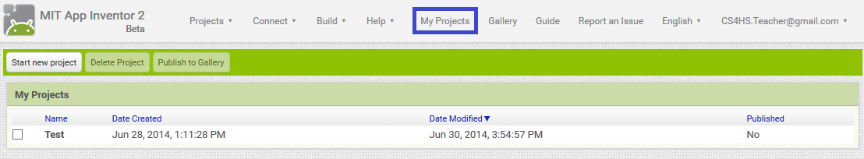

Click the *Start new project* button and name the project “Magic8Ball”. After a few seconds the project should load and you will see a screen similar to that below.



Select and drag a *Button* over to the screen as shown above.

Now click the textbox below the *Image* heading highlighted in blue in the above image.

Click the *Upload File …* button and you will be presented with a dialog similar to that shown below. Click the Browse… button, which will open a file upload dialog. In the file upload dialog navigate to the folder where you extracted the activity resources and select *image_8_ball.jpg..*



Your app layout should now look like this:



We should get rid of that text in the middle of the 8ball image. To do this, highlight the text in the *Text* textbox highlighted in blue in the image above and delete this text.

Now are are going to add the playing of a sound when the 8ball image is tapped. Select and drag a Sound control from the *Media* Palette onto the canvas, as highlighted in blue in the below image. If the Sound control was added successfully it will appear in the Non-visible components section, as highlighted in orange below.



Next we have to upload the sound to play when you tap the 8ball. To do this click on the box below the *Source* heading highlighted in blue above. Click on *Upload File …* then click *Browse…* and navigate to the folder where you extracted the activity resources. There are three different sounds to choose from:

* *Cha_Ching.mp3*
* *Clinking_Teaspoon.mp3*
* *Tada.mp3*

Select one of these files, whichever you like the best, click *OK* and the file will upload.



Once the file has uploaded, it should be listed in the Media section on the bottom right and the filename (in this example I have chosen *Tada.mp3* for the sound) should be in the *Source* textbox, as shown above.

Now it’s time to start using the *Blocks Editor*. Click on the *Blocks* button on the top right of the screen, next to the *Designer* button, as highlighted in blue below. The screen should change to look something like is shown below.



Once the *Blocks Editor* is open, you should see the *Button* and *Sound* that you added to the canvas in this tab, as highlighted in green in the image above.

Now click on the **Button1** block, and you will get a list of available blocks for the **Block1** *Button*. Drag and drop the “when *Button1.Click do”* block onto the canvas as shown below:



All command blocks that are put inside this “when *Button1.Click do”* block will be run when the 8ball button is clicked.

We now need to add a command to play the “tada” noise when the **Button1** button is clicked. To do this, click on the **Sound1** block. Drag the *“call Sound1.Play*” block inside the “when *Block1.Click do”* block and it should click into place as shown below:



Now we’ll give the app a run by clicking the *Connect* button at the top of the screen and selecting *USB*. Once the app is running, tapping on the image of the 8Ball should play the sound you chose (make sure the tablet is not muted).  
  
Part 2: Showing a Random Answer

Next we’ll add the displaying of a random answer when tapping the 8ball image. We will use 2 *Label* controls for this part:

* 1 *Label* control for displaying instructions for using the app
* 1 *Label* control for displaying the random answer

We will put these *Label* controls into what is called a *VerticalArrangment* control so that one *Label* is displayed on top of the other. To do this, first make sure that you are in the Designer view (you should be able to see the app layout with the 8ball image).

Next, select and drag a *VerticalAlignment* control from the Layout palette onto the canvas. This is highlighted in blue in the image below:



We will now add the *Label* controls to the *VerticalArrangement* control.

Select the User Interface palette, then select a Label control and drag it into the *VerticalArrangement* control. The *VerticalArrangment* control will be represented by a gray rectangle with a black border, as can be seen in the image below.



Change the text of this *Label* to “Ask the Magic 8-Ball a question” by deleting the text in the Text property (highlighted in orange above) and replacing it.

Now we will add the other Label beneath the first by dragging another *Label* control onto the canvas, making sure that it is still in the *VerticalArrangment* control but below the first *Label*. This is shown in the image below.



Change the text of the second *Label* to “Touch the Magic 8-Ball to receive your answer.”, by editing the text in the Text property, as you did for the first *Label* control.

The second *Label* will be used to display the random answer when tapping the 8Ball. We will update this text using blocks in the Blocks Editor.

Now that we have the *Label* controls on the canvas, we will add blocks to choose answers to your questions randomly. Change to the Blocks editor by clicking the *Blocks* button in the top right corner.

In the Blocks editor, select **Label 2**, then select the block titled *“set Label2.Text to”* and drag it into the *“when Button1.Click do”* block, as highlighted in blue below.



Now we will add the blocks to choose an answer randomly. Select *Lists* from the left-hand side. Next, select and drag the *“pick a random from list”* block so that it clicks into the *“to”* part of the *“set Label2.Text to”* block, as shown in blue below.



Next we will drag a “make a list” block and place it so that it clicks in the “list” part of the “pick a random item list” block as shown in blue below:



Next we will add the different answers to the list we make. The usual answers on a magic 8-Ball are listed below, but you can substitute answers with other text if you’d like.

* It is certain
* Without a doubt
* As I see it, yes
* Ask again later
* Reply hazy, try again
* Don’t count on it
* My sources say no
* Outlook not so good

To add these answers to the list, select the *Text* block in the Built-in section, and drag a *“ ”* block over to one of the sockets in the *“make a list”* block. You can edit the text in the “” block by double clicking and typing the text in. To begin with add the first answer (“It is certain”) to the list, by following the steps shown below.



Repeat the last step, but this time change the text in the “ “ block to the second random answer (“Without a doubt”) and place the block in the second socket.   
  
You will notice that the two sockets on the “make a list” block are full. The “make a list” block allows you to add as many sockets (items in the list) as you’d like. To add more sockets to the block, first click the dark blue button on the “make a list” block. Next, in the dialog that opens drag an item block on the left hand side into the list block on the right hand side, as pictured below.



Continue to add items to the list block until you have a total of 8 sockets (2 of which will be already filled by the first 2 text blocks).   
  
Next, add the rest of your answers to the list by following the steps you took to add the first 2 Text blocks. You can also copy and paste the Text blocks if you’d like, which may be faster then choosing them from the Text section. Your final result should look similar to that below:

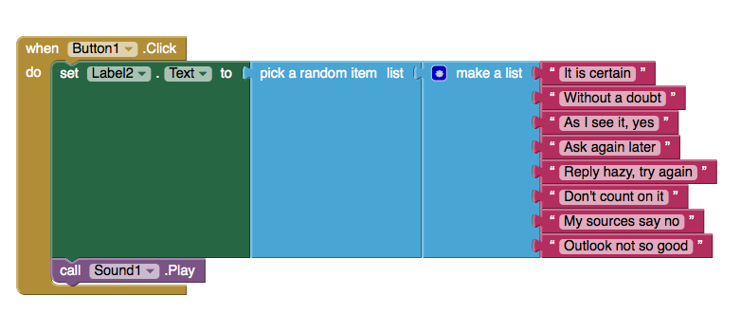

Now, try the app. Ask a question you want answered, tap the 8ball image and see what answer you get.

## Part 3: Shaking to Show a Random Answer

After completing Part 2, you now have a working 8Ball app. In this part of the tutorial we will make the app more like a real magic 8-ball. Instead of tapping the image, you will now be able to shake the table to receive a random answer.

To tell when the tablet is being shaken we will use the tablet’s accelerometer. An accelerometer is a sensor that measures acceleration of the phone in 3D space. Accelerometers are used for many different purposes, one example is when you rotate a phone or tablet and the display changes to landscape or portrait accordingly. Other uses of accelerometers include games where you tilt a phone or tablet as a method of control, and estimating the number of steps you have taken.

AppInventor allows you to interact with many different sensors available to tablets and phones, not only the accelerometer. The other sensors that are available to use can be seen in the Sensors menu in the Designer view.

For this tutorial we will only be using the *AccelerometerSensor* control. Firstly, make sure that you are in the Designer view. If you are still in the Blocks Editor, click the Designer button in the top right corner.

Next, select the *Sensors* Palette, then drag an *AccelerometerSensor* control onto the canvas as shown in blue below. If the control has been added successfully it will be visible in the Non-visible components, as highlighted in orange below.



Now we will add the blocks to choose a random answer when the phone is shaken. Switch to the Blocks Editor by clicking the *Blocks* button in the top right corner.

In the Blocks menu, select **AccelerometerSensor1** and drag the *“when AccelerometerSensor1.Shaking do”* block anywhere on the canvas, as pictured below.



We want to move the updating of the label with a random answer into the “when AccelerometerSensor1.Shaking block”, so that it happens when the tablet is shaken instead of when the image is tapped. To do this, select the *“set Label2.Text to”* block and move it out of the *“when Button1.Click do”* block. When you drag the *“set Label2.Text to”* block this will drag all the connected blocks along with it. The result should look similar to that shown below.

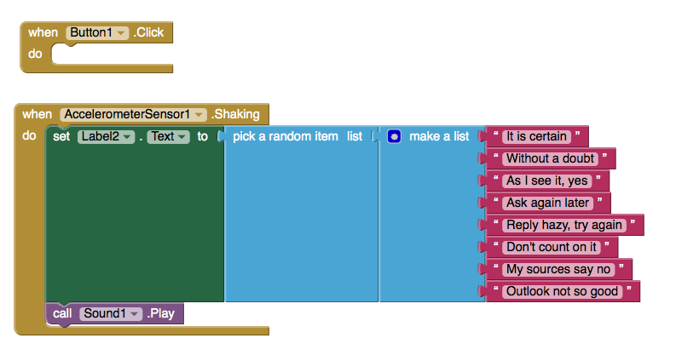

Finally, delete the *“when Button1.Click do”* block by selecting it and tapping your delete key, or moving it into the trashcan.

Now you can test the app. Ask a question and shake the tablet. Every time you shake the tablet, the bottom *Label* should now change to one of the random answers and your chosen sound will play.

Good work, you have successfully completed the Magic 8-Ball app tutorial!